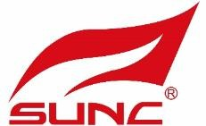

Outdoor
Sun Shade Solution
SHANGHAI SUNC INTELLGENCE SHADING TECHNOLOGY CO., LTD.
- Aluminium Pergola ● Zip Screen ● glasses ● Outdoor Blinds

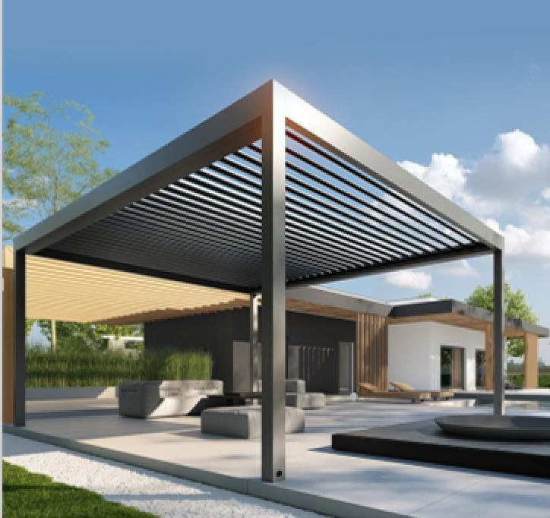
Introduction
Aluminium Pergola System from SUNC is a great way to provide all year round weather protection from the elements, with the option of Aluminium Pergola and sides screen creating a totally enclosed area. Available in many design options, the Aluminium Pergola has a fully retractable canopy cover, which at the touch of a button can be extended to provide shelter, or retracted to take advantage of the good weather. The canopy offers a flat surface that guarantees the discharge of rain water.

Application：
- Private residence, villa and other civil areas
- Commercial venues: hotels, restaurants, stores
- Garden supporting facilities engineering

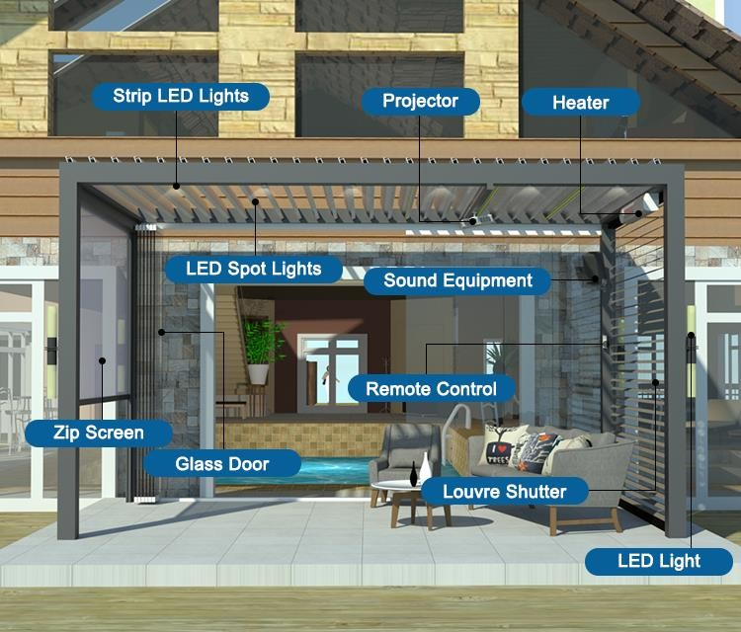
Product Showing (all can be added in with pergola)

Specification-Control
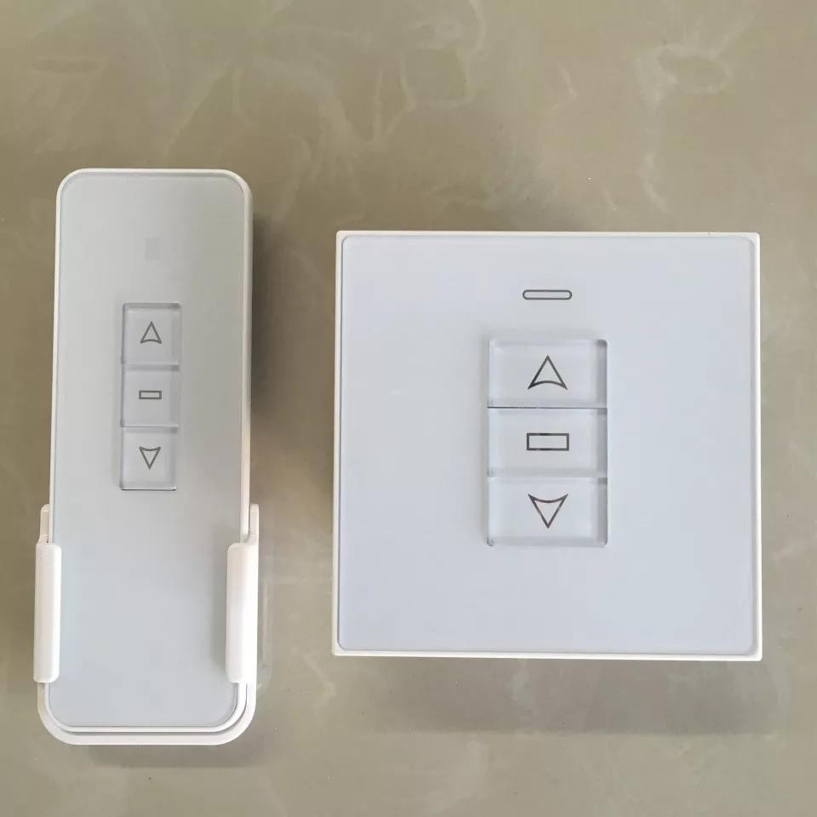
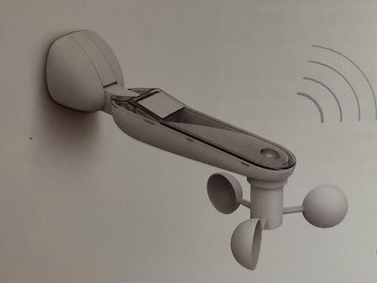

Handle Control/On-wall Control for your choose Outdoor wireless wind-sun sensor for reference

Specification
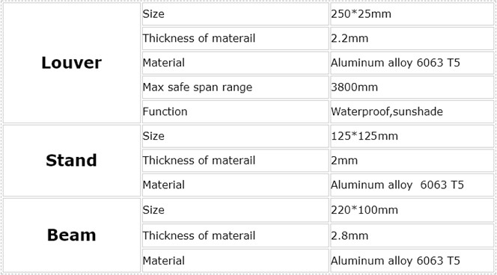
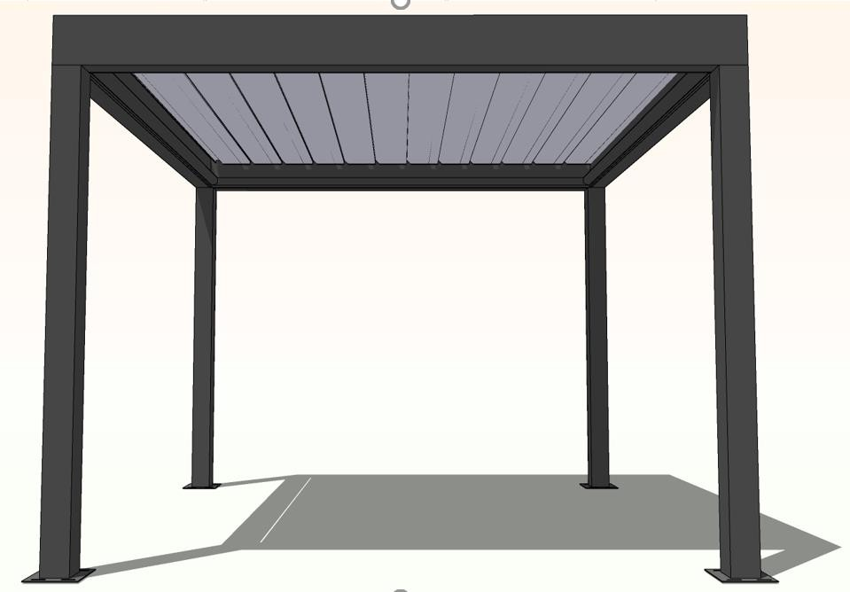

Specification-Color

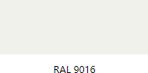
Louver color
Normal ：RAL 9016/RAL7016 Any RAL Color for your choose

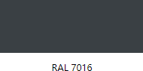
Frame color Normal ：RAL 9016
RAL 7016

Specification
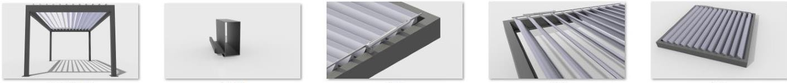

Pergola Exploded view
Drainage channel Details 1

Details 2
Details 3

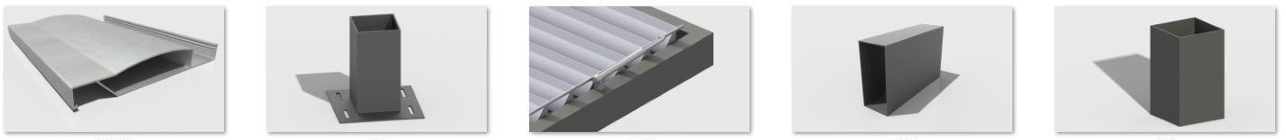

Blade
Bottom plate

Motor Beam Column

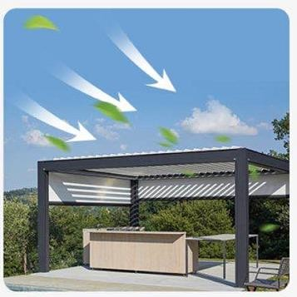Functions
Wind Resistance
Adjust louver to close ,effectively prevent wind.
Zip track can be match purchase together,Then can be in the wind for you to build a warm viewing place.
Adjust louver to open ,can feel the breeze

Sun Resistance
Operate blade closure to effectively block UV;
Operate blade to Open ,so you can feel the sunlight scattering you build your own outdoor viewing deck.

Rain Resistance
Operating blade closure can effectvely block rain water.

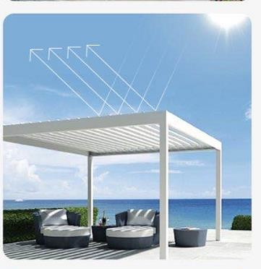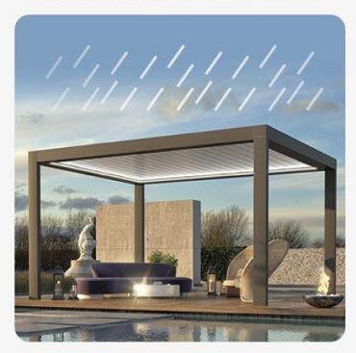

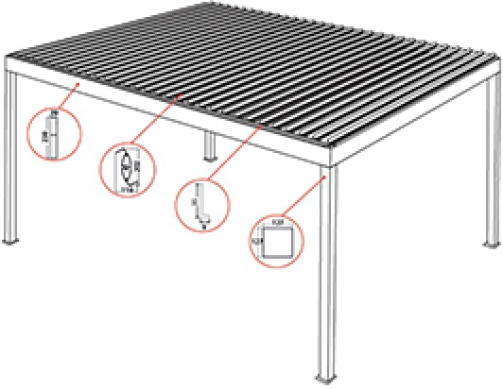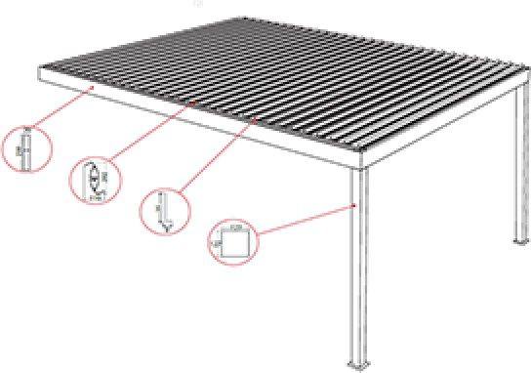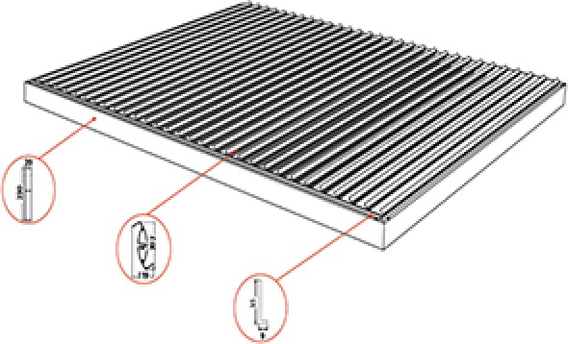

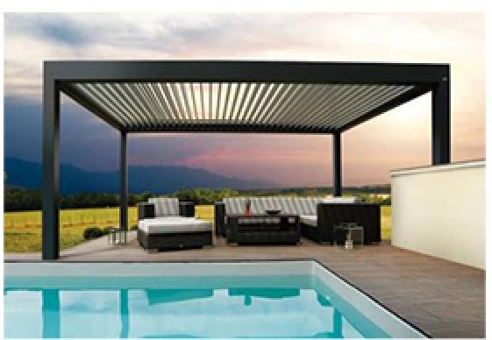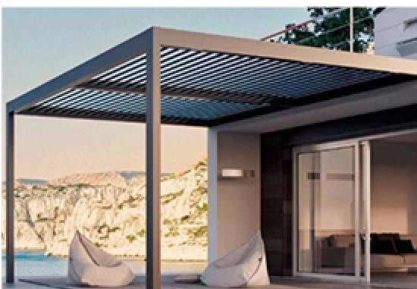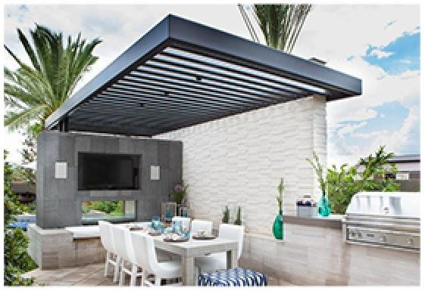

Ground Support Unilateral Cloumn Card Wall

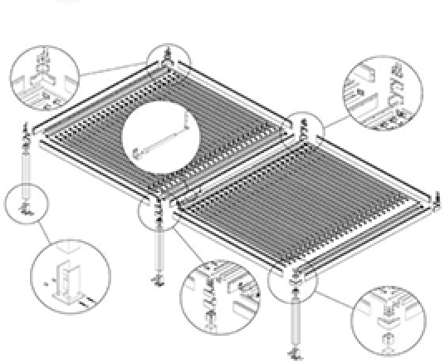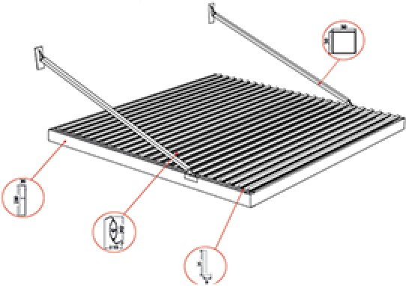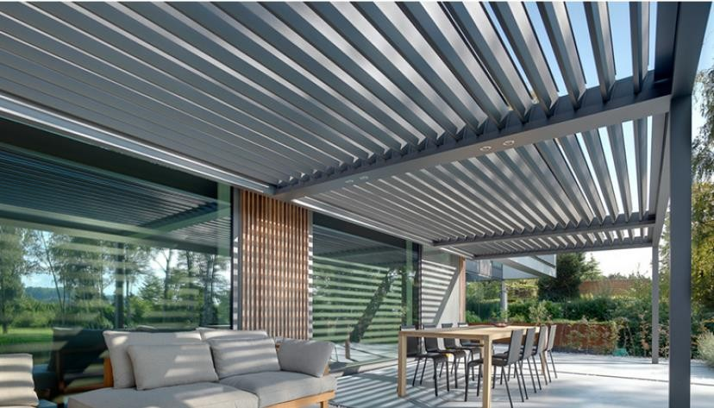

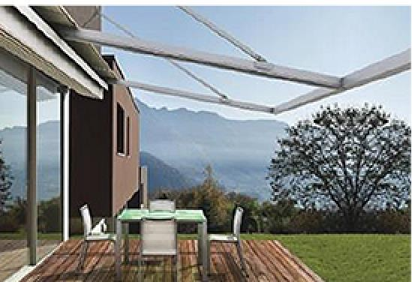

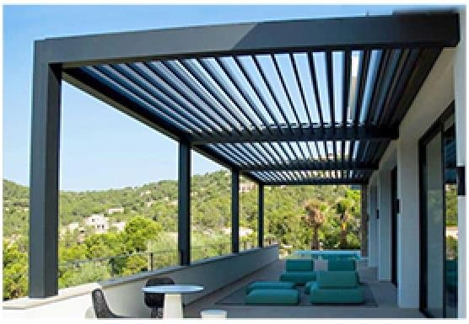
Unilateral Cloumn

Wall Mounted
Various installation methods can be developed according to site and customer requirements.

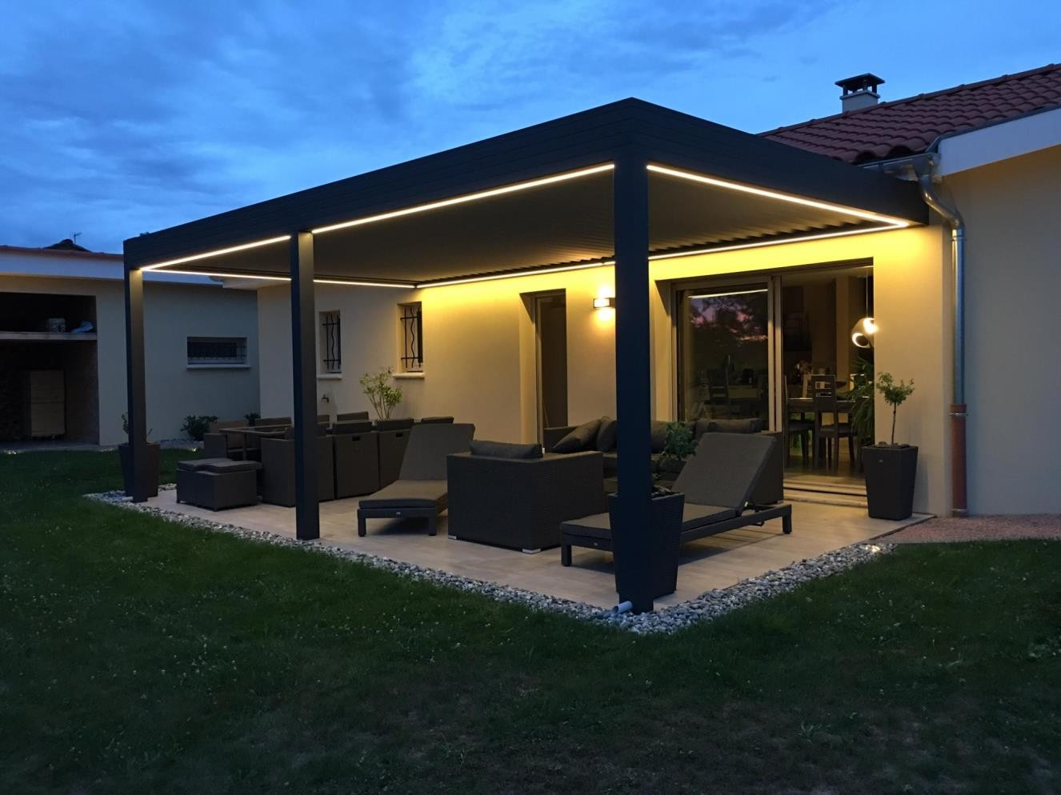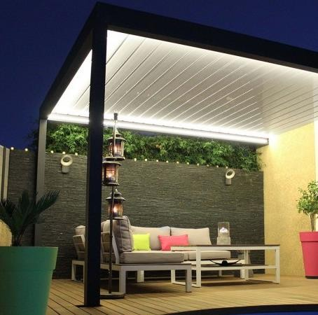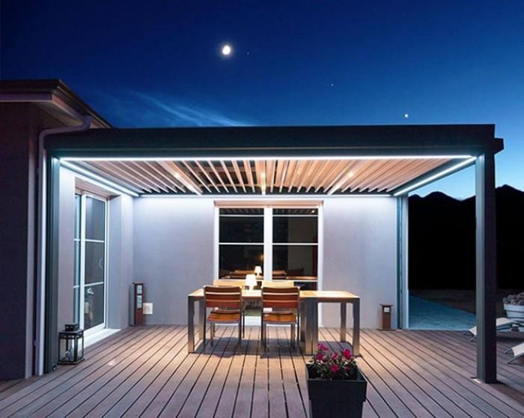Application—LED light

Application—Outdoor Pool side
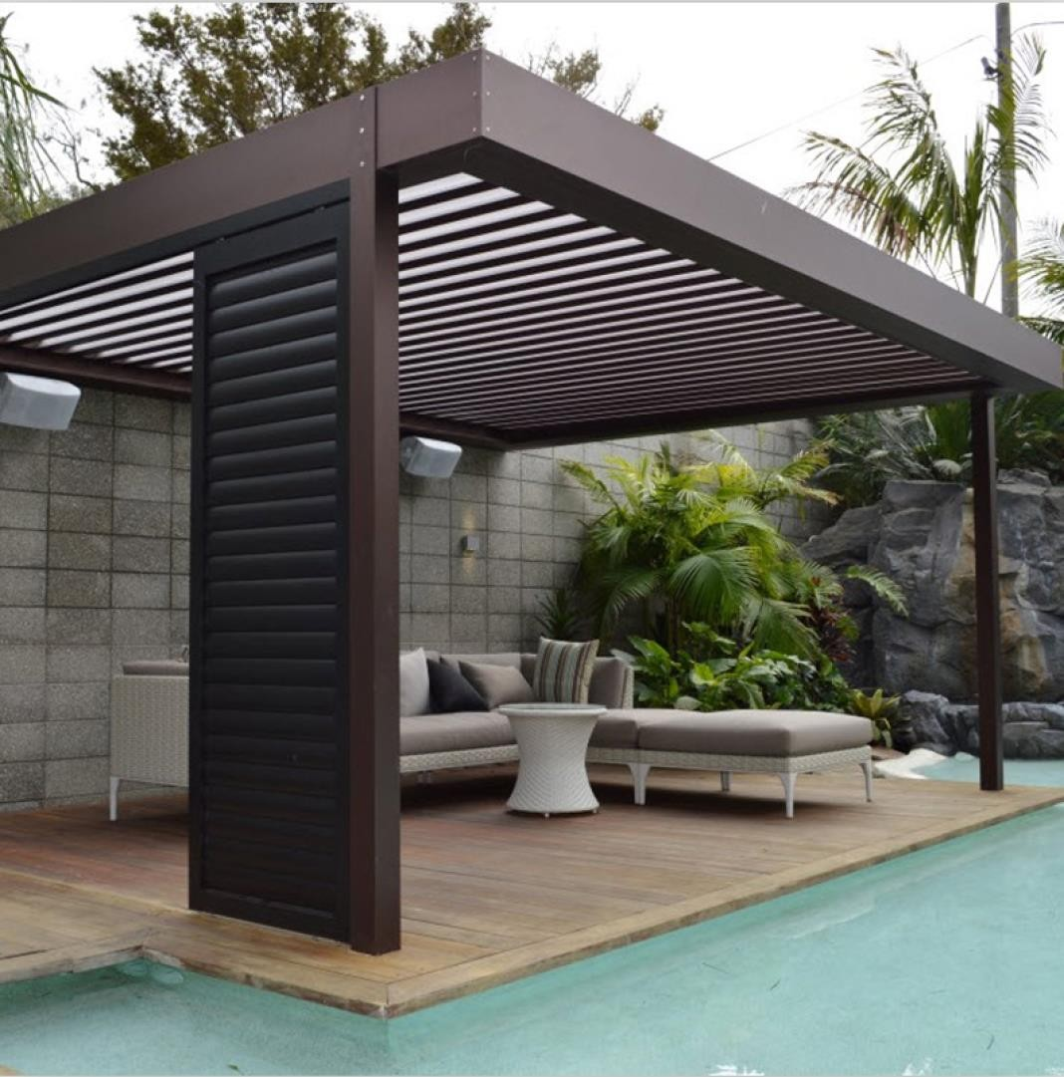
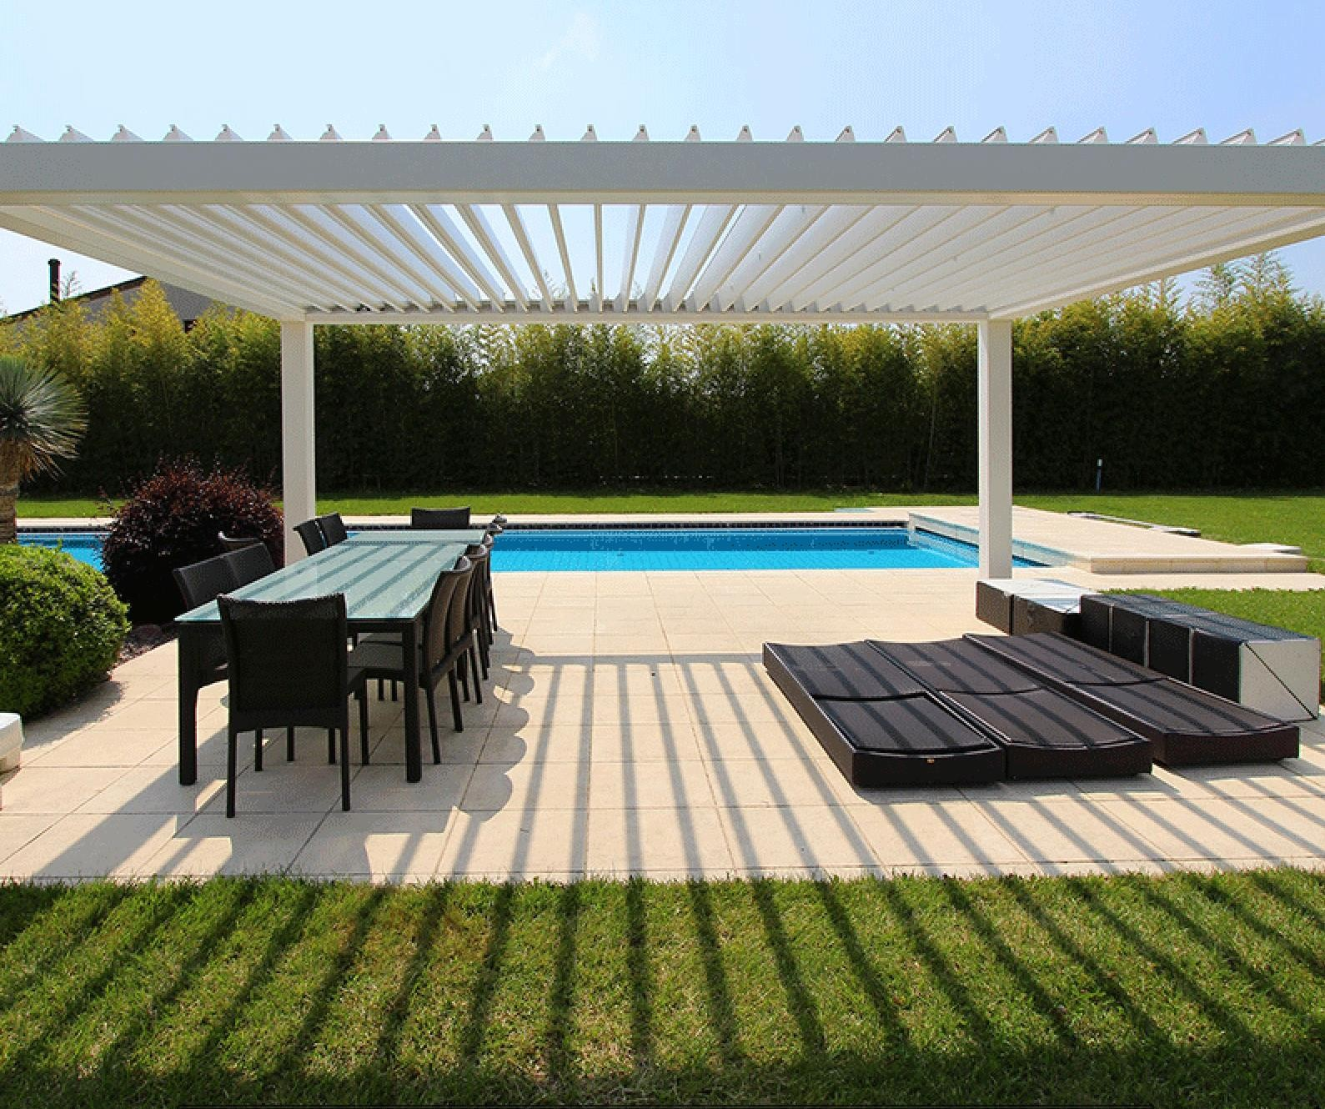

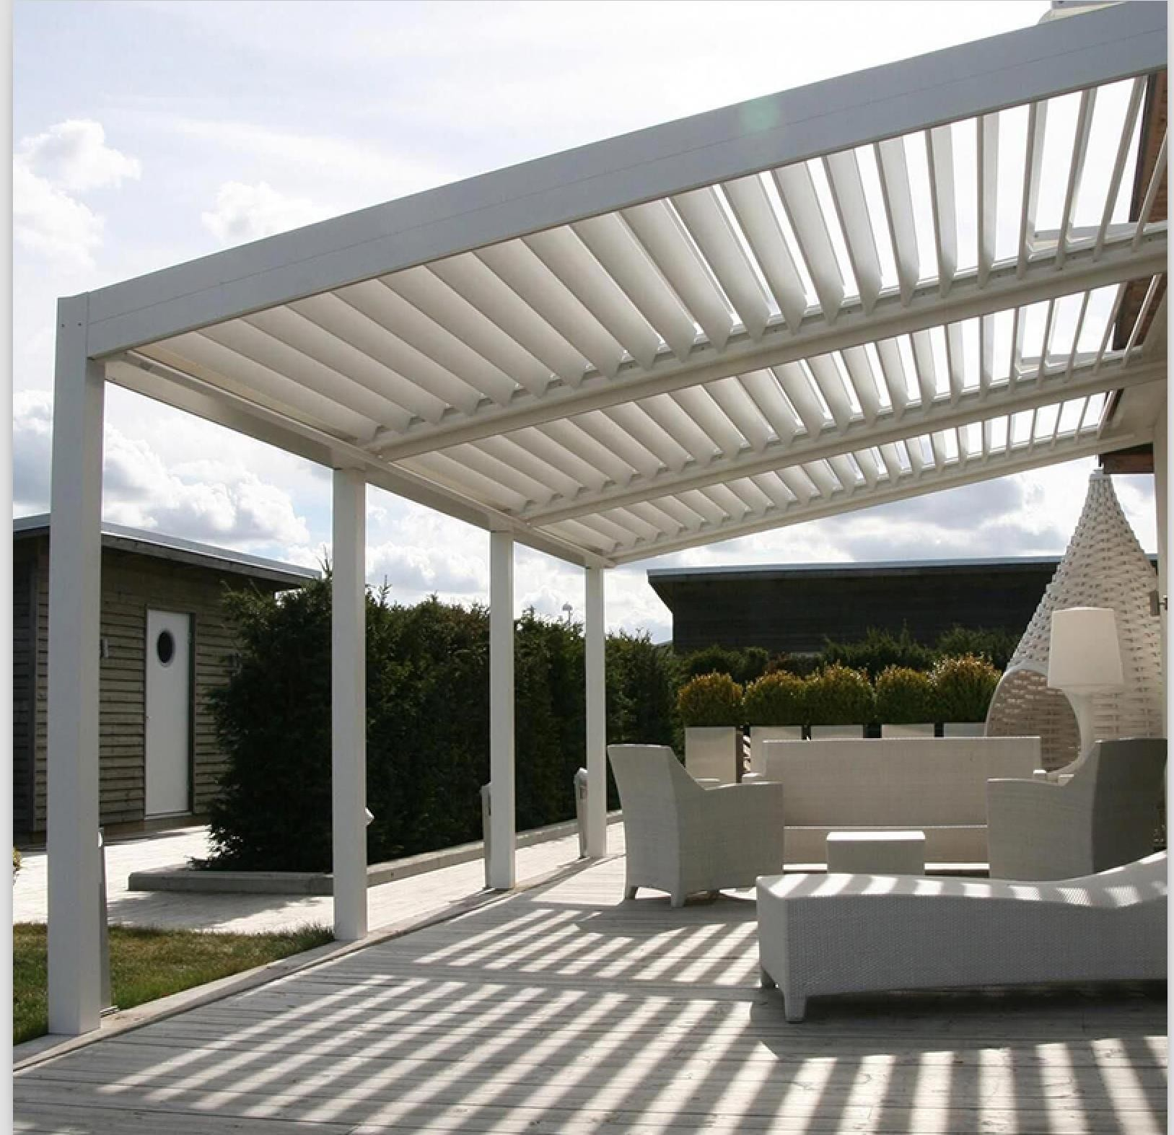
Application— Open Platform

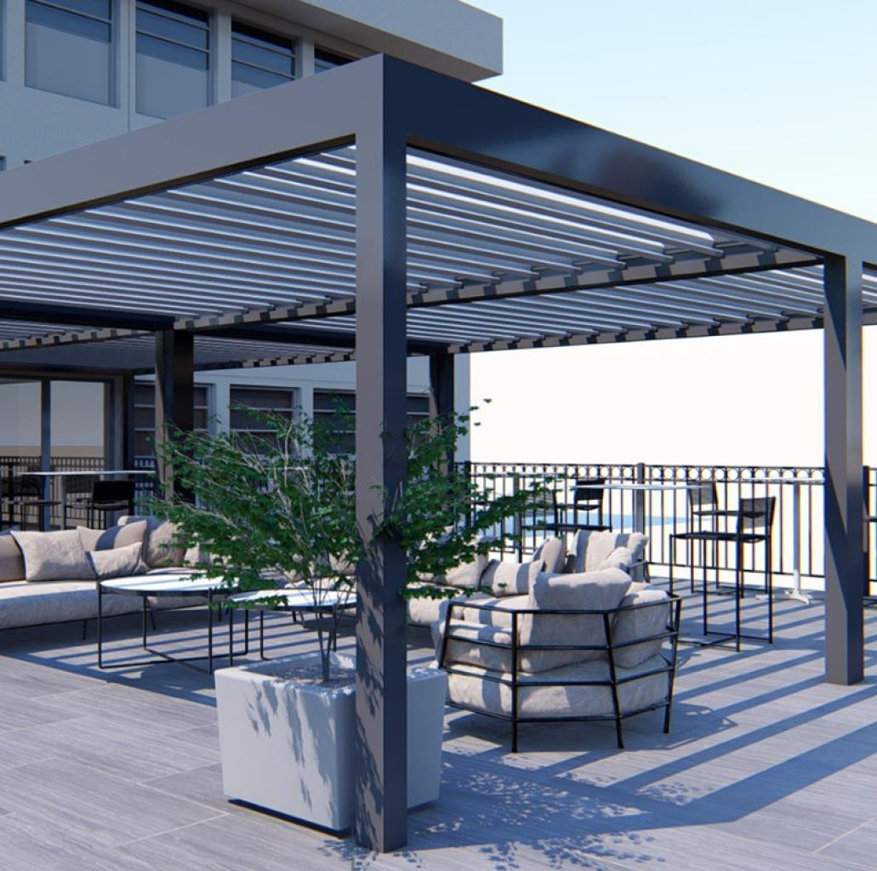

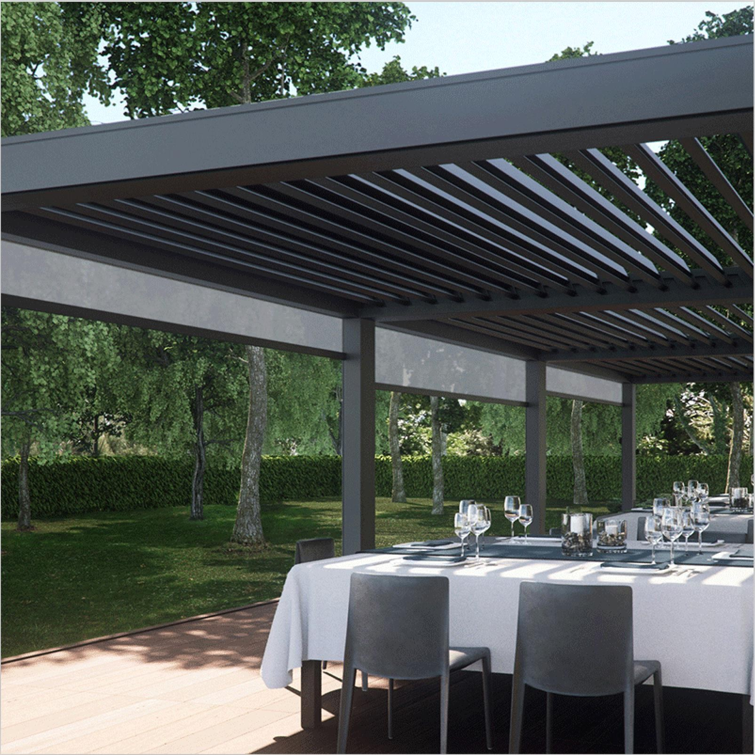

Application—Restaurant

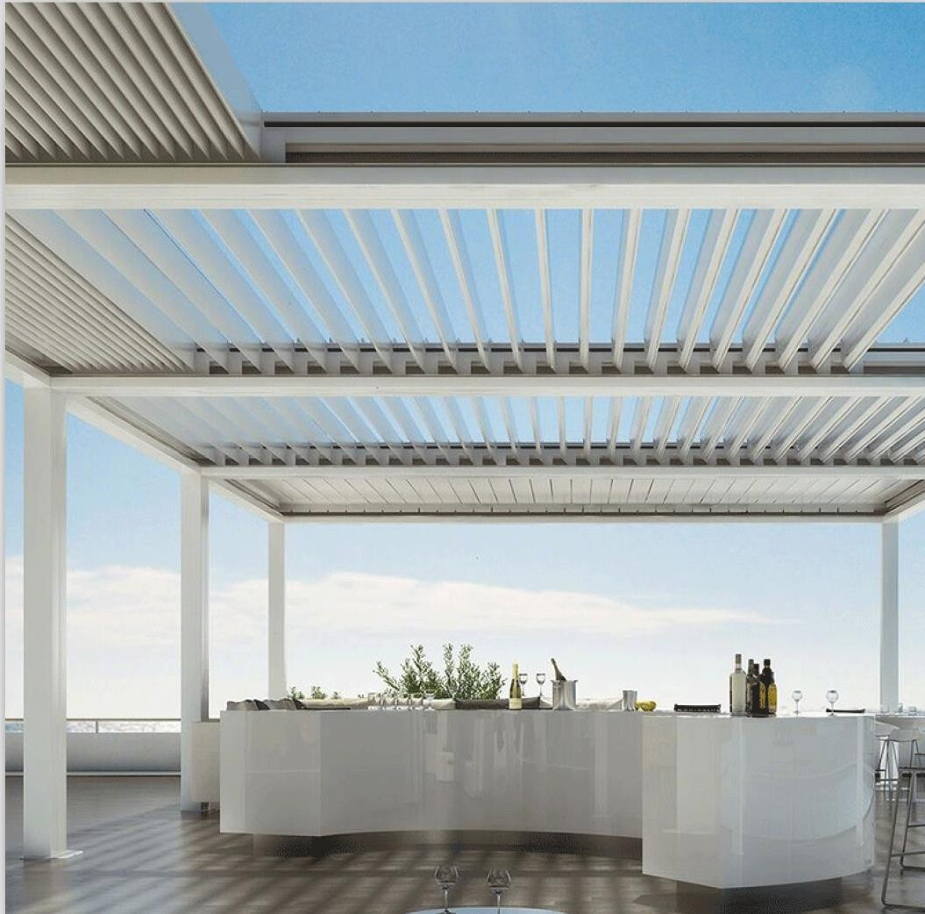

Application—Garden Outdoor space

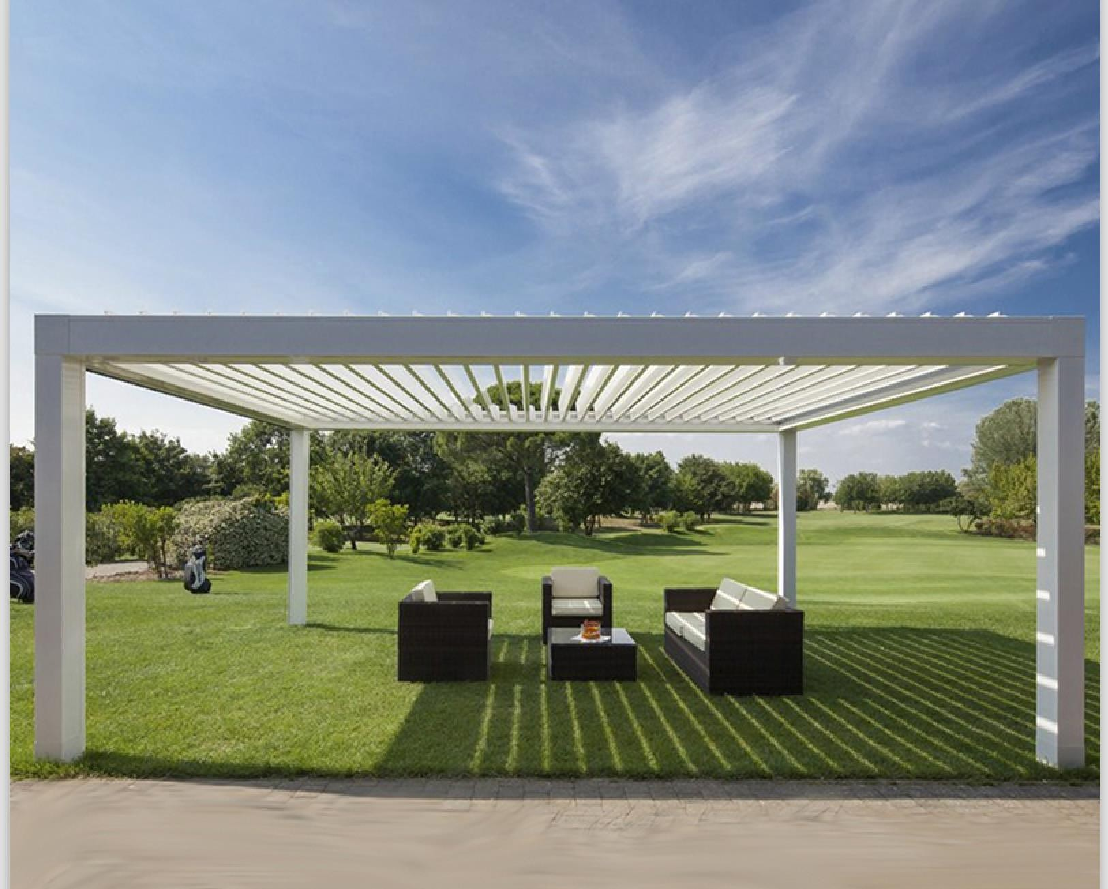

About us

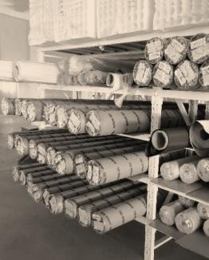
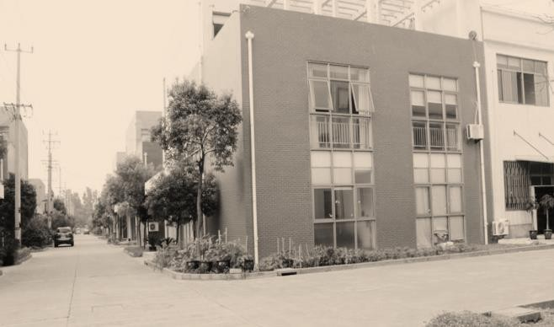
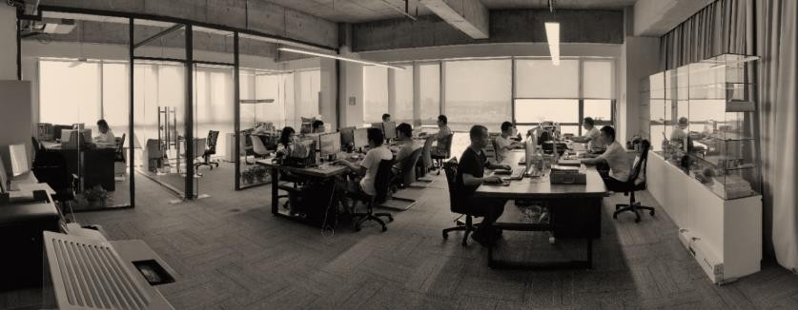
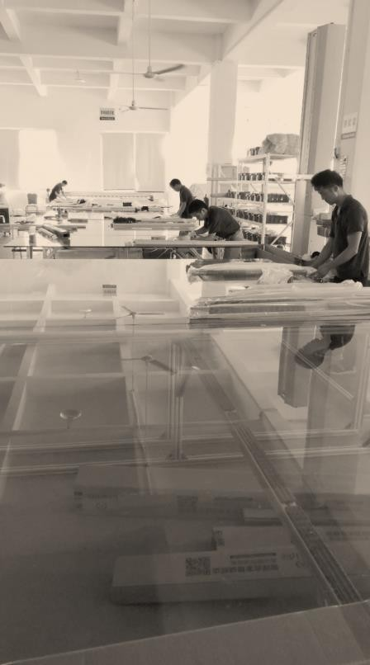
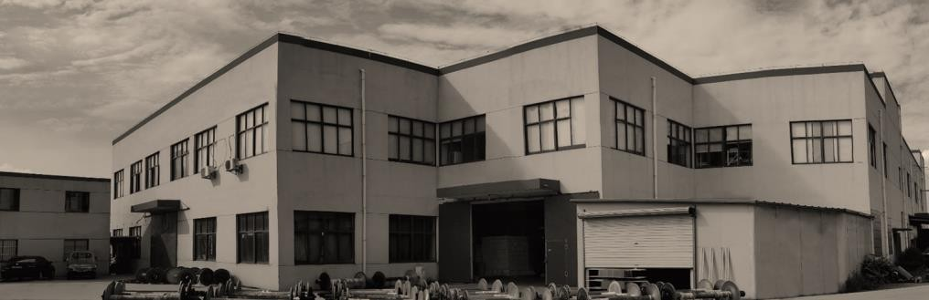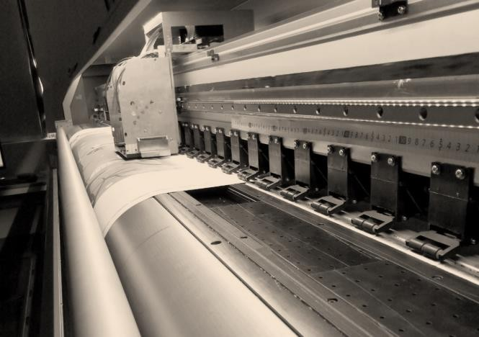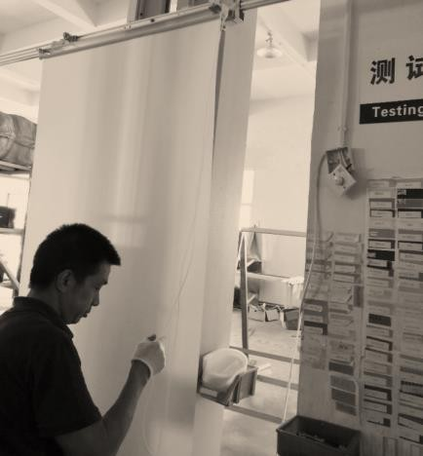SUNC Group is mainly engaged in providing outdoor architectural solutions for builders, contractors as well as end customers globally. Our product ranges cover Aluminum Pergola, Aluminium Pergola, Aluminum Sun Louvers, Louver Shutter, Garden Greenhouse, Louvre Window, Louver Frame, Accessories, with wide application in commercial buildings and residential house , school for both decorative and practical use purpose. We're growing and open to any cooperative relationships. We are not only a aluminum products supplier, we are also a aluminum solutions company who can give you new design products based on your need.

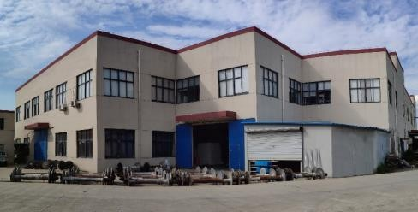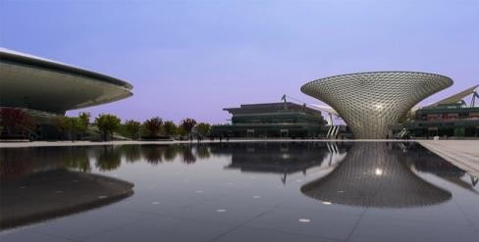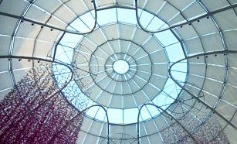

Build own factory in Suzhou, obtained numbers of sunshade national patents

2008
Participated in Madrid pavilion/Mercedes-benz performing center project

2010-2011
Participate in Wanda plaza/Longhu tianjie/China resources Mixc/SM projects

2015-2017

2009
Set up Foreign Trade Department in Songjiang

2012-2014
Participate in Hotel project :
Marriott/Hyatt/Intercontinental/Windham

2017 - Now
Opened foreign market like Europe, North America , South America, Mid-east

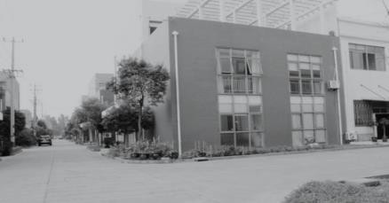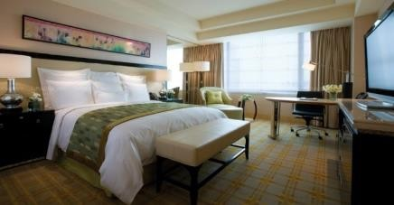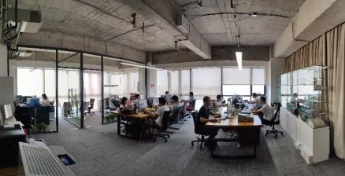

Our strength

The business license
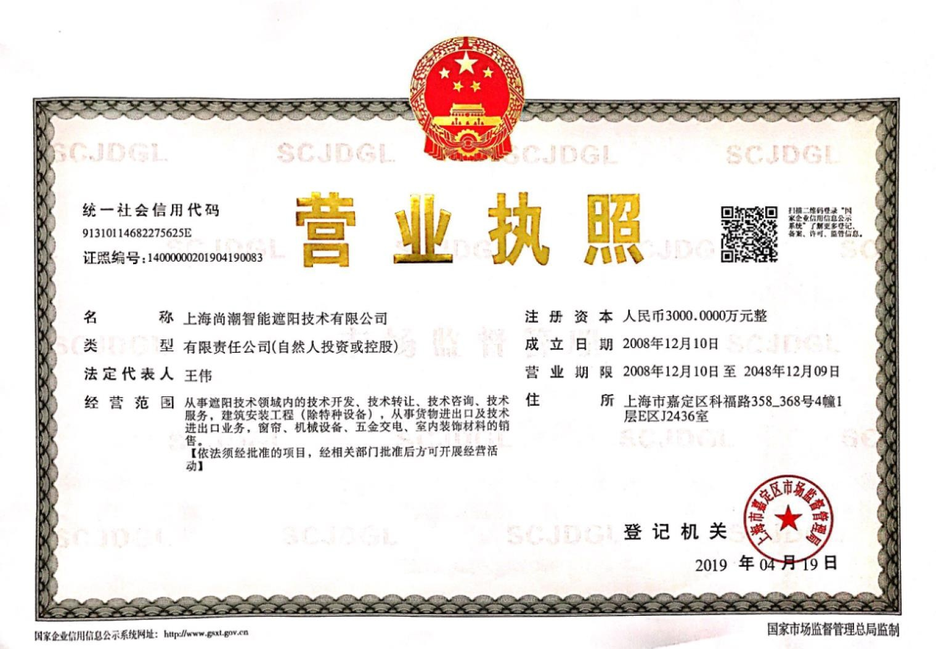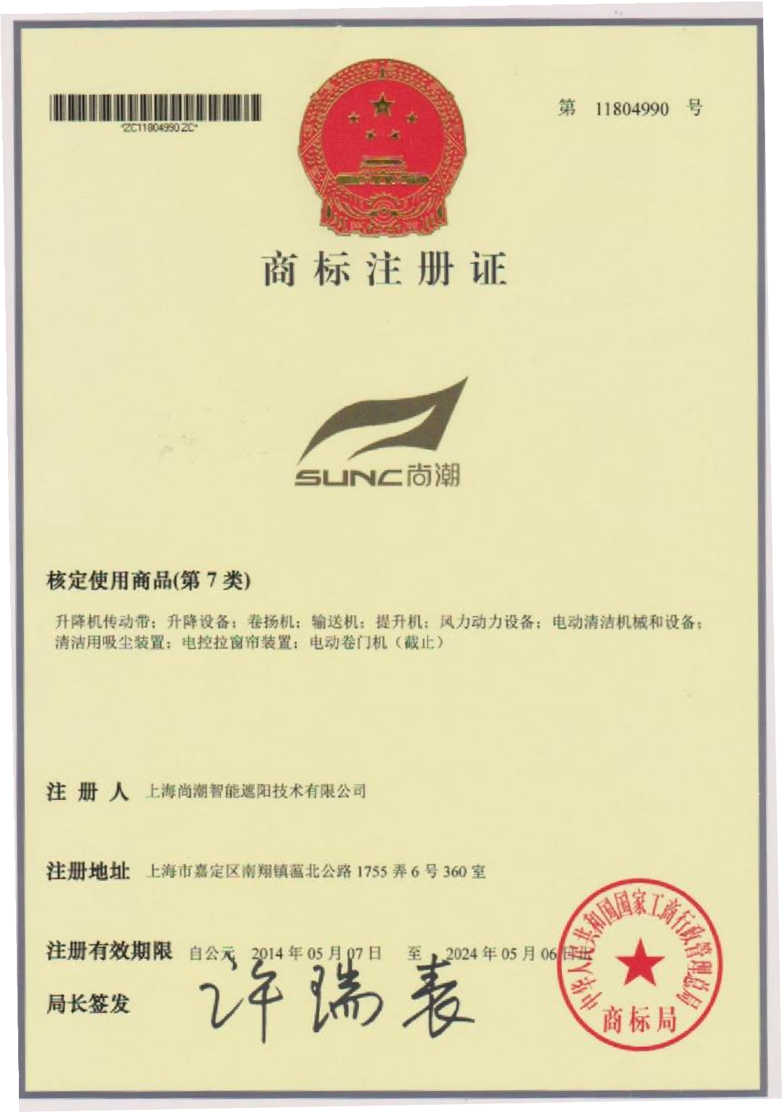

Certificate
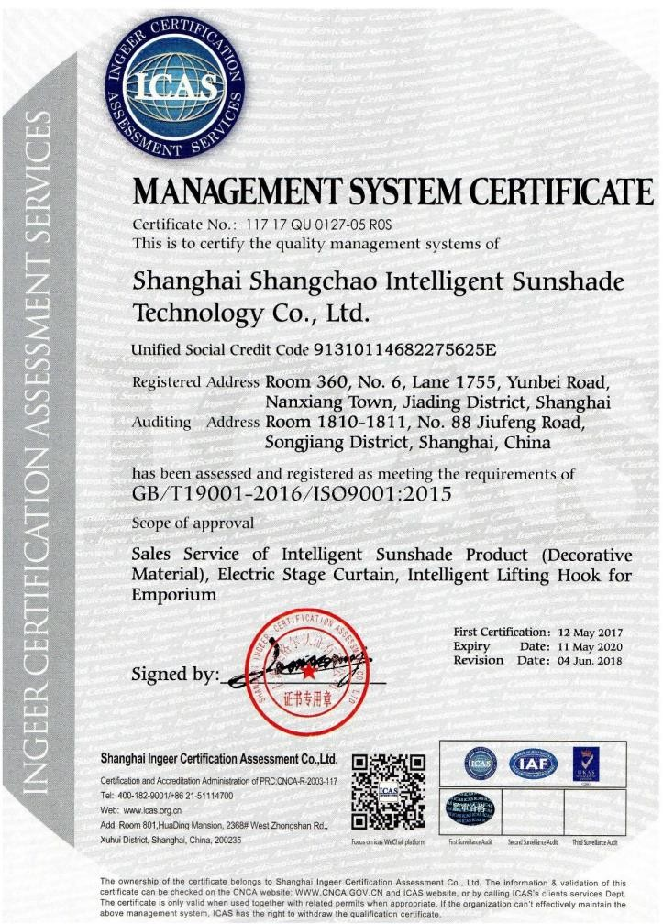
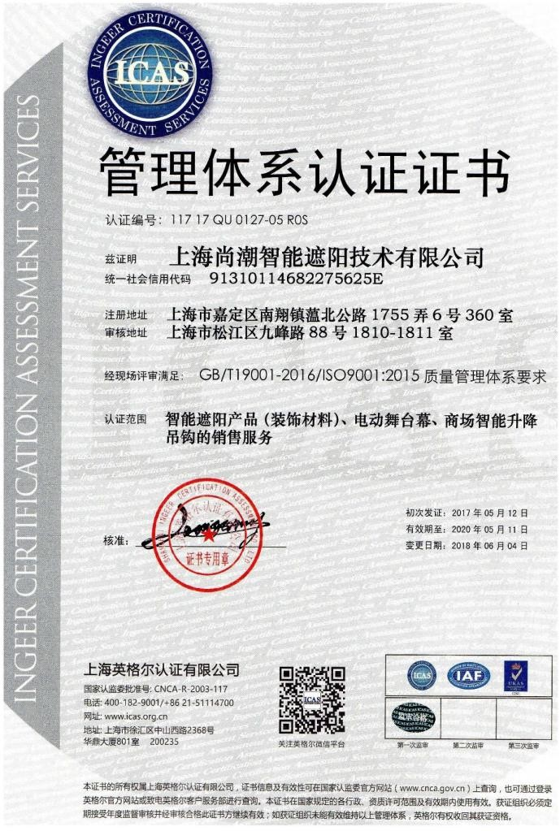
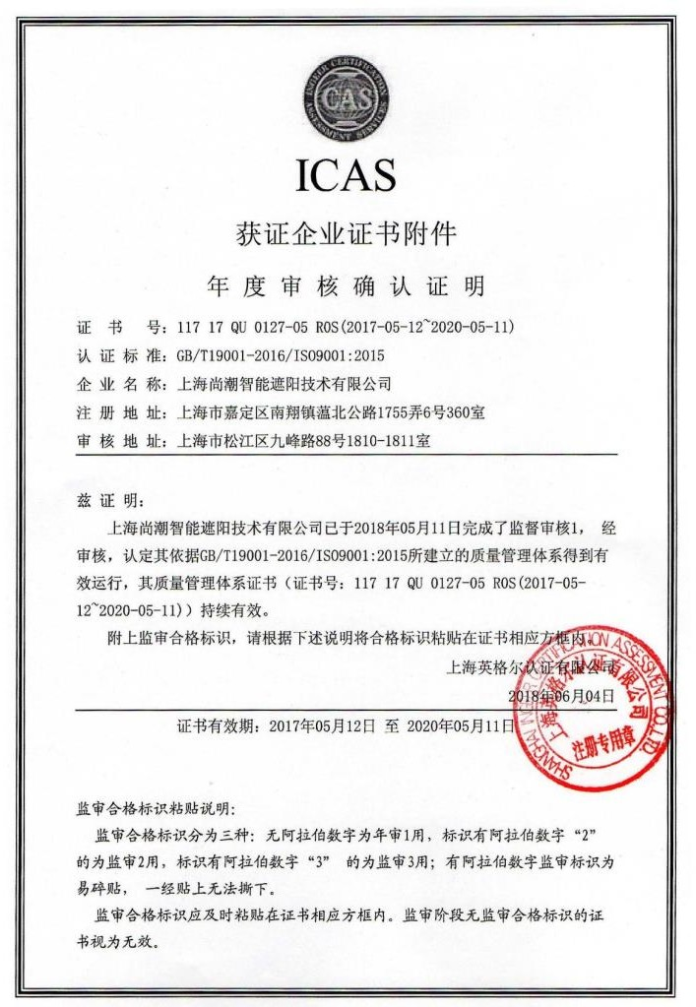
GB/T19001-2016 / ISO9001:2015 Management system certificate

numbers of sunshade national patents

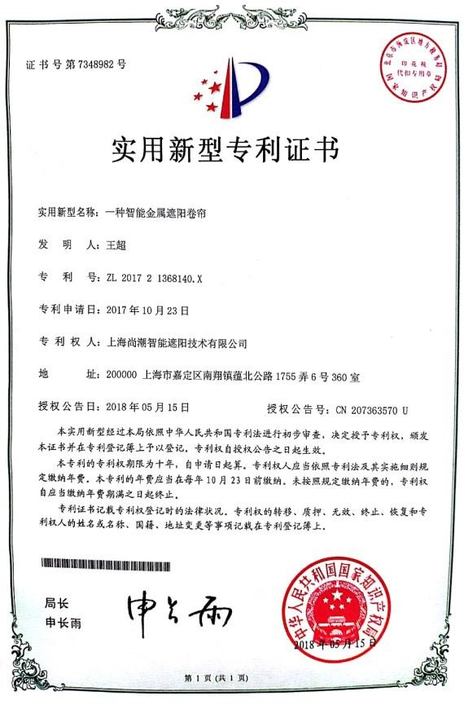
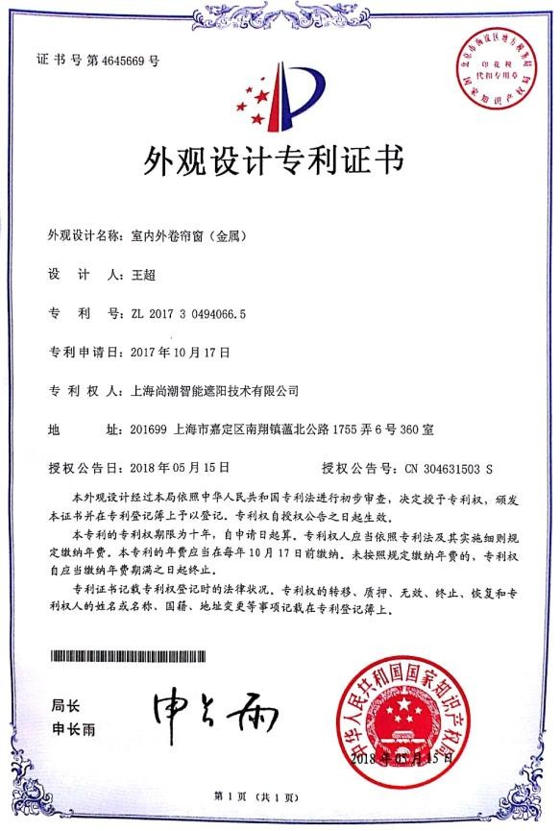
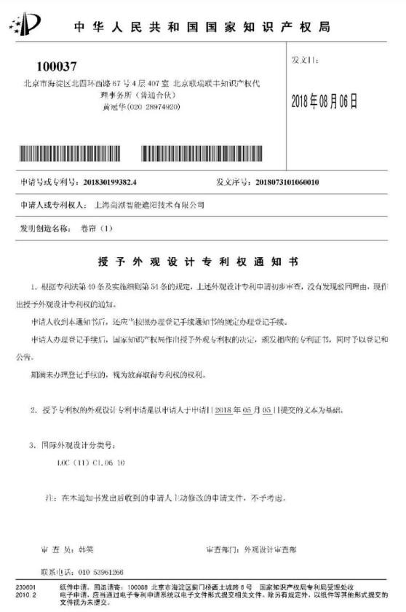
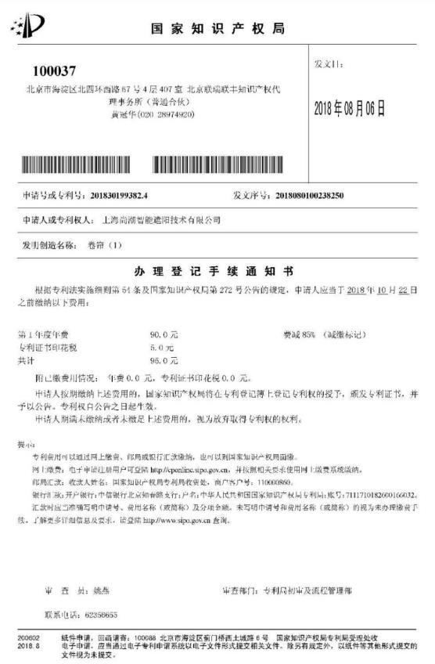

Thanks！
SHANGHAI SUNC INTELLGENCE SHADING TECHNOLOGY CO., LTD.

